Hotel Revenue Analysis
MODULE – I

Introduction
The Hotel Revenue Analysis project is a Business Intelligence (BI) initiative designed to help hotel management understand performance metrics, revenue drivers, and customer booking behaviours.

Project Goals:
- To load Booking, Customer, Room, and Branch data.
- To build a robust Star Schema for performance optimization.
- To derive key metrics such as Booking Duration, Room Category Segmentation, and Stay Type.
- To visualize revenue drivers, such as top-performing branches and preferred room types.

1. Theoretical Framework: The Star Schema
A star schema is a type of data warehouse model that organizes data into a central fact table surrounded by dimension tables. A Star Schema organizes data into a central "Fact Table" surrounded by "Dimension Tables."
  - Schema Architecture

1. Fact Table (Bookings):
  - The central table containing the metrics for analysis.
  - Measures: Total_Amount (Revenue), Nights_Stayed.
  - Foreign Keys: Links to dimension tables (Date_ID, Room_ID, Customer_ID, Branch_ID).
2. Dimension Tables:
  - Date: Time-based attributes (Year, Quarter, Weekday, Holiday).
  - Room: Room attributes (Type, Bed Count, Price, Amenities).
  - Customer: Customer details (Name, Age, Gender, Loyalty).
  - HotelBranch: Location details (City, State, Manager, Star Rating)
1.2 Why This Schema Works for Hotels
This schema is ideal for hotel analytics because:
- Simplifies Queries: It streamlines complex questions regarding revenue, occupancy, and customer behaviour into simple joins.
- Optimized for Dashboards: It reduces processing time, making Power BI reports faster and more responsive.
- Scalability: It scales easily; new branches or years of data can be added without restructuring the entire model.

2. Data Creation & Formulas (Excel)

2.1 Fact Table (Bookings)
The Fact table sits at the centre of the schema. It contains the quantitative data (metrics) and Foreign Keys (FK) that link to dimension tables. Bookings Table consists of 25K records.

Excel Formulas:

- BookingID = Primary Key of Bookings Table in sequence B001, B002 etc

- DateID = IFNA(XLOOKUP(F2, Date!B:B, Date!A:A, "ID Not Found"), "Check Date Format")

- CustomerID = Primary Key of Customer Table in sequence C0001, C0002 etc

- RoomID = Primary Key of Room Table in sequence R001, R002 etc

- BranchID = SWITCH(TRIM(UPPER(C4)),
"R001", "BR001",
"R002", "BR004",
"R003", "BR003", "R004", "BR002", "R005", "BR005",
"UNKNOWN")
- CheckInDate = Date in the format ‘dd-mm-yyyy’ when Customer Checked in the hotel.

- CheckOutDate = Date in the format ‘dd-mm-yyyy’ when Customer Checked Out the hotel.
- Nights_Stayed = CheckInDate – CheckOutDate

- Stay_Type = IFS(H2<=1, "Day use", H2<=3, "Short stay", H2<8, "Extended stay", H2>=8, "Long stay",TRUE,"Undefined")

- BookingStatus = Status of Bookings with values, Checked-in, Cancelled, No Show

- Cancellation Reason = if I2 = Cancelled, then J2 = either of (Wrong Dates, Hotel Issues, Bad Weather, Family Emergencies, Price Issues)

- PaymentMethod = Mode of Payment like Credit Card, Debit Card, Cash, UPI, Online Wallet

- Purpose = Consists of Purpose of bookings like Wedding, Vacation, Business, Conference, Leisure etc

- BookingChannel

=SWITCH(TRIM(UPPER(O3)),
"BUSINESS", CHOOSE(MOD(ROW(),3)+1,"Website","Call Center","Corporate Portal"),
"CONFERENCE", CHOOSE(MOD(ROW(),3)+1,"Travel Agent","Call Center","Website"),
"VACATION", CHOOSE(MOD(ROW(),3)+1,"Mobile App","Website","Travel Agent"),
"WEDDING", CHOOSE(MOD(ROW(),2)+1,"Travel Agent","Website"),
"LEISURE", CHOOSE(MOD(ROW(),2)+1,"Mobile App","Website"),
"OTHER", CHOOSE(MOD(ROW(),2)+1,"Website","Call Center"),
"UNKNOWN","Website"
)

- RoomNightsSold =SUMIFS(H2,I2,"Checked-in")

- Revenue =VLOOKUP(C2,Room!A:E,5,FALSE)*H2

- MonthStart =EOMONTH(F2, -1) + 1

- SourceType =IF(OR(N2="Website", N2="Mobile App"), "Direct", "OTA")

- DiscountApplied =Random Values of (0,5,10,15)

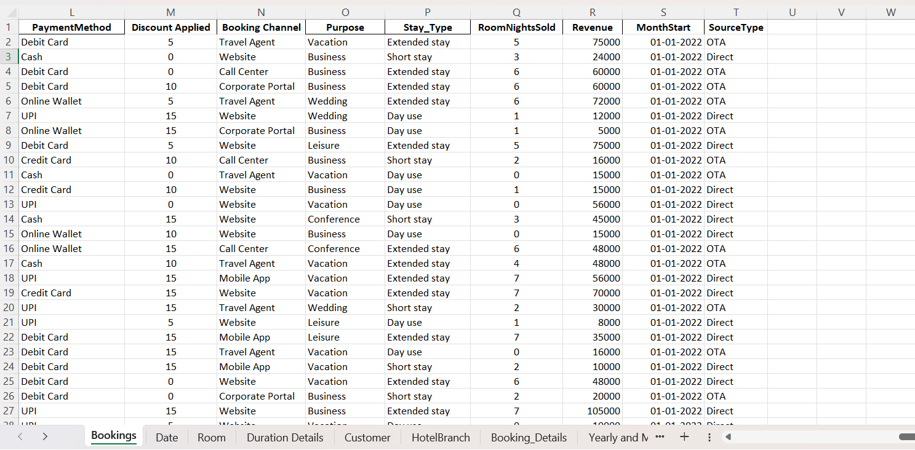

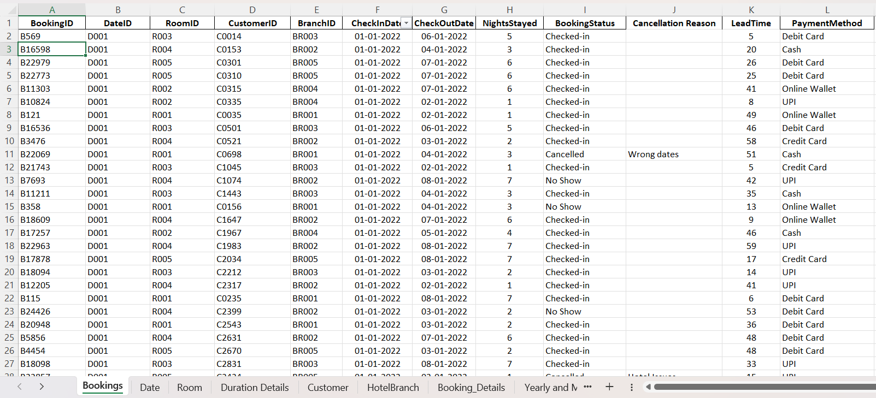
2.2 Dimensions Table

2.2.1 Room: A continuous list of dates covering the analysis period (e.g., 2022-2024).
Excel Formulas:
- RoomID =Primary Key of Room Table of values like R001, R002, R003, R004, R005
- RoomType = Room Type Values like Single, Executive, Suite, Double, Deluxe
- BedType = King, Queen, Twin
- Capacity = RANDBETWEEN(1,4)
- PricePerNight =
IF(TRIM(B2)="Single",5000,
IF(TRIM(B2)="Double",8000,
IF(TRIM(B2)="Deluxe",10000,
IF(TRIM(B2)="Executive",12000,
IF(TRIM(B2)="Suite",15000,0)))))
- Room_Category =
=IF(E2<6000, "Standard",
IF(E2<12000, "Premium",
IF(E2<18000, "Luxury",
"Ultra")))

- AmenitiesList=
SWITCH(TRIM(UPPER(B2)),
"Single", "Safe, TV, Bed, MiniBar",
"Double", "WiFi, DoubleBed, TV, AC, Safe",
"Deluxe", "WiFi, TV, AC, CoffeeMaker, Balcony, Safe", "Executive", "WiFi, TV, AC, CoffeeMaker, Couch, DoubleBed, Balcony, Safe", "Suite", "Wifi, AC, TV, Balcony, DoubleBed, Couch, CoffeMaker Safe, RoomDining",
"UNKNOWN")

- Occupancy = Under Maintenance, Occupied, Available

- BranchID = IFS(A2="R001", "BR001", A2="R002", "BR004", A2="R003", "BR003", A2="R004", "BR002", A2="R005", "BR005")

- IsSeaFacing = IF(E2<10000, FALSE, TRUE)

- IsAC =IF(E2=5000, FALSE, TRUE)
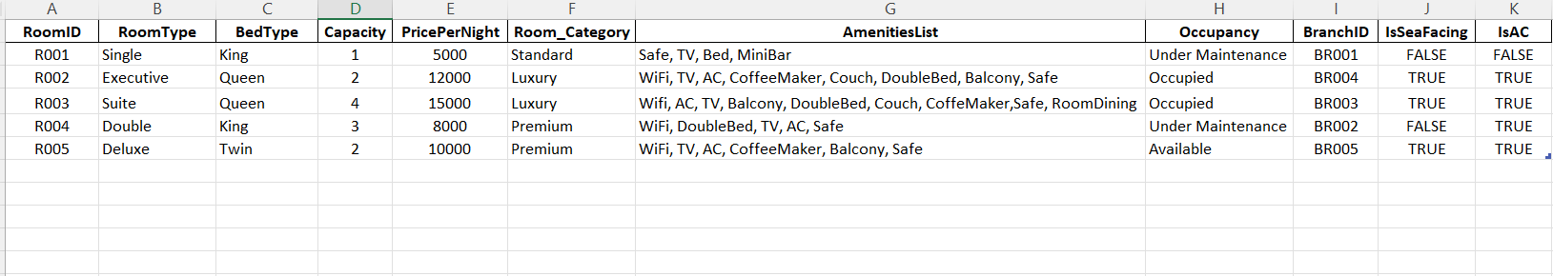

2.2.2 Customer: A database of Customers and their Details.
Consists of 5K records of Customers with Columns like CustomerID, Name, Gender, Age, Country, Email, Phone, Tier.
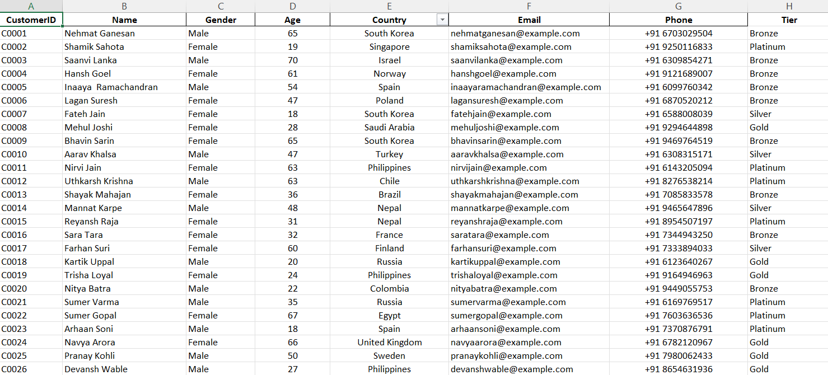

2.2.3 HotelBranch: Fixed locations of the hotel chain. There are total 5 branches, i.e Mumbai, Delhi, Hyderabad, Bangalore, Chennai.
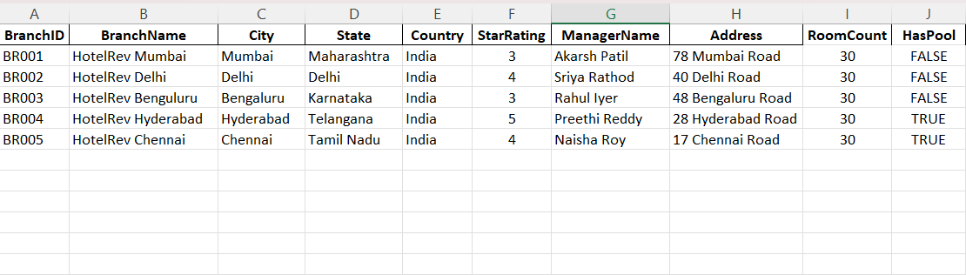
Consists of attributes like BranchID, BranchName, City, State, Country, Star Rating, Manager Name, Address, RoomCount, HasPool
2.2.4 Date: A continuous list of dates covering the analysis period (e.g., 2022-2024).
Excel Formulas:
- DateID: Primary Key of Date Table in sequence D001, D002…..etc
- FullDate: Each Date ranging from 01-01-2022 to 31-12-2024
- Day =DAY(B2)
- Month =MONTH(B2)
- Year=YEAR(B2)
- Weekday=TEXT(B2, "dddd")
- FiscalQuarter ="Q"&ROUNDUP(MONTH(B2)/3,0)
- IsHoliday = Assigns Boolean values.

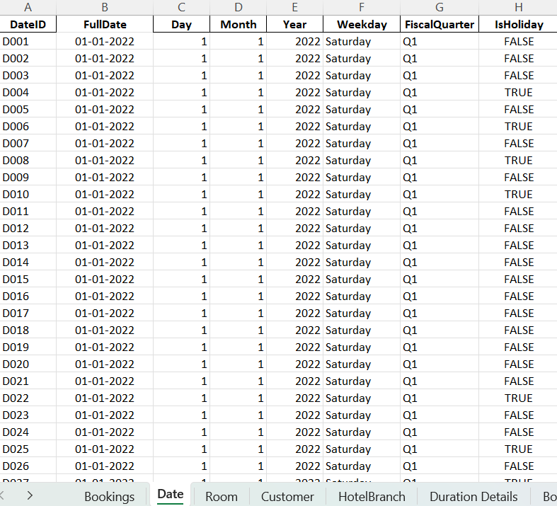

3. Importing Data into PowerBI
Once the Excel file is saved (e.g., HotelDB.xlsx), follow these steps in Power BI Desktop:
- Get Data: Click Home > Get Data > Excel Workbook.
- Selection: Select the file and check the boxes for all 5 tables (Bookings, Date, Room, Customer, HotelBranch) and click Load

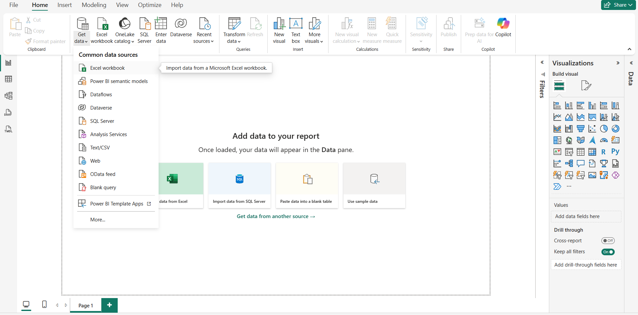
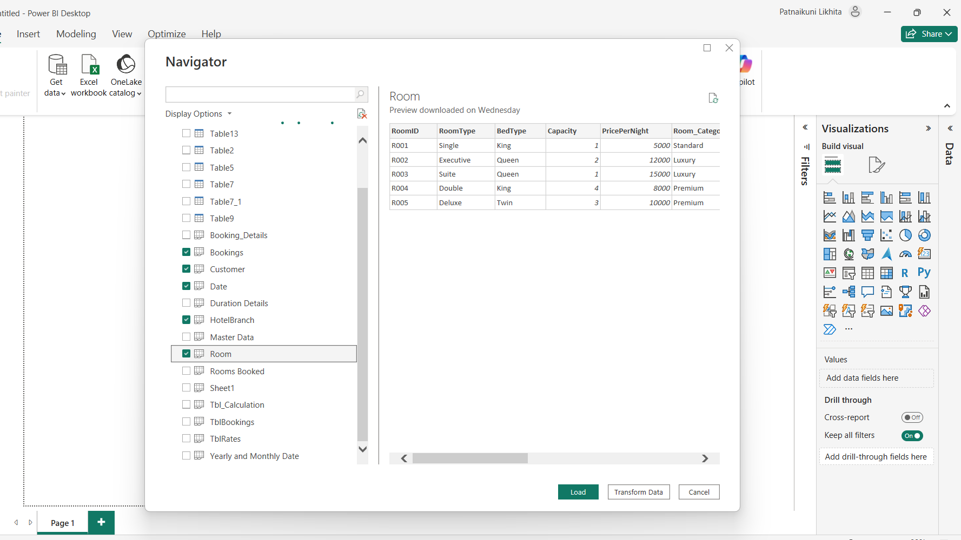

- Transform Data (Power Query):
  - Click "Transform Data" to enter Power Query Editor.
  - Check Data Types:
    - Ensure Total_Amount is set to Fixed Decimal Number (Currency).
    - Ensure CheckIn_Date and Full_Date are set to Date.
    - Ensure all IDs are set to Text (or Whole Number, provided they match across tables).
  - Load: Click "Close & Apply".
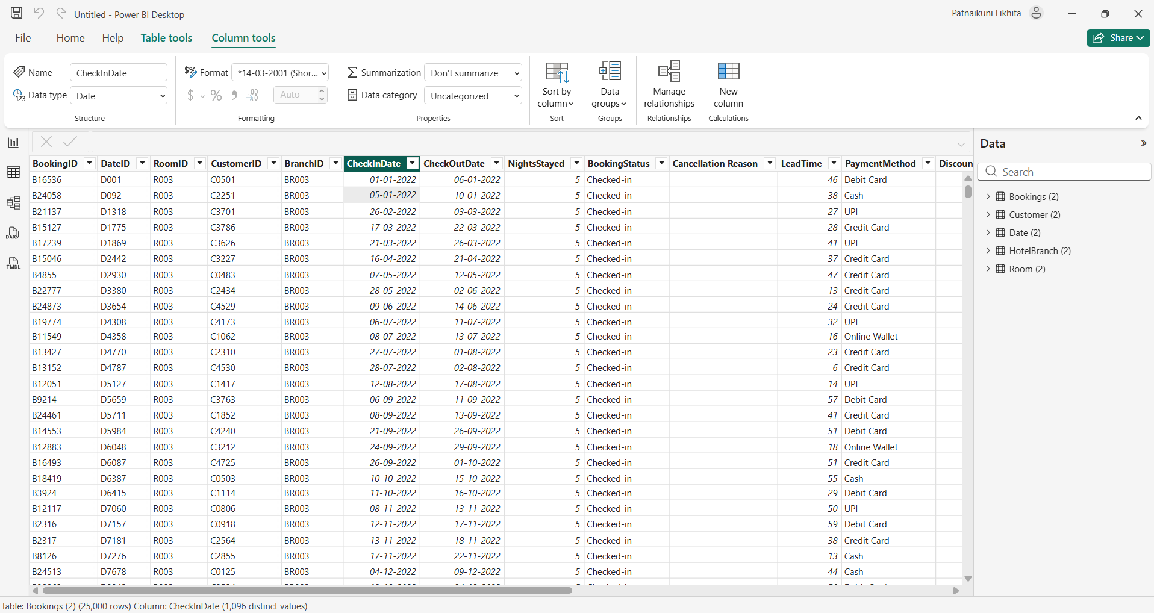

- Creation of PowerBI Visuals:

We have to create visuals for better analysis of Hotel Bookings, We will be creating 4 visuals:

4.1 Count of BookingID by Stay_Type
4.2 Average of NightsStayed by RoomType
4.3 Count of NightsStayed by BranchID
4.4 Sum of Revenue by BranchName

Go to the Report View for creating Visuals.

4.1 Count of BookingID by Stay_Type
- Select Visual: In the Visualizations pane, click on the Pie Chart icon.
- Add Data:
  - Legend: Drag the Stay_Type field (from Bookings table) into the Legend.
  - Values: Drag BookingID into the Values well.
- Configure Aggregation:
  - By default, Power BI might "Sum" the ID if it is a number. Click the small arrow next to BookingID in the Values and select Count.
- Formatting (Paintbrush Icon):
  - Go to Format Visuals > Detail labels > Label contents.
  - Go to General > Title > Give Title for the visual
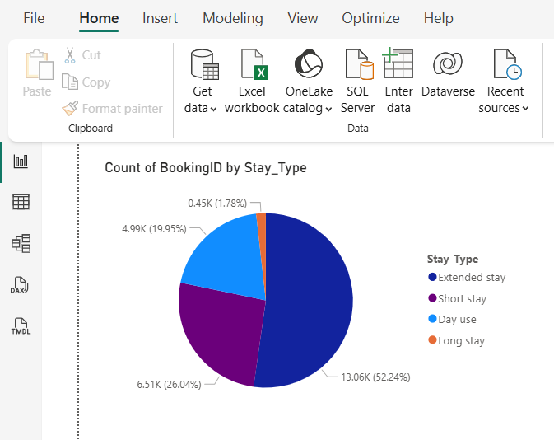
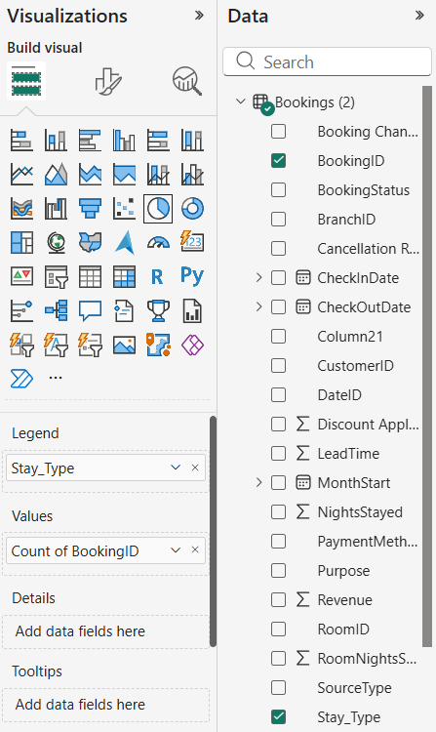

4.2 Average of NightsStayed by RoomType

- Select Visual: Click on the Clustered Bar Chart icon (horizontal bars).
- Add Data:
  - Y-Axis: Drag RoomType (from the Room table) into the Y-Axis.
  - X-Axis: Drag NightsStayed (from the Bookings table) into the X-Axis.
- Configure Aggregation:
  - Click the arrow next to NightsStayed in the X-Axis well and change it from Sum to Average.
- Formatting:
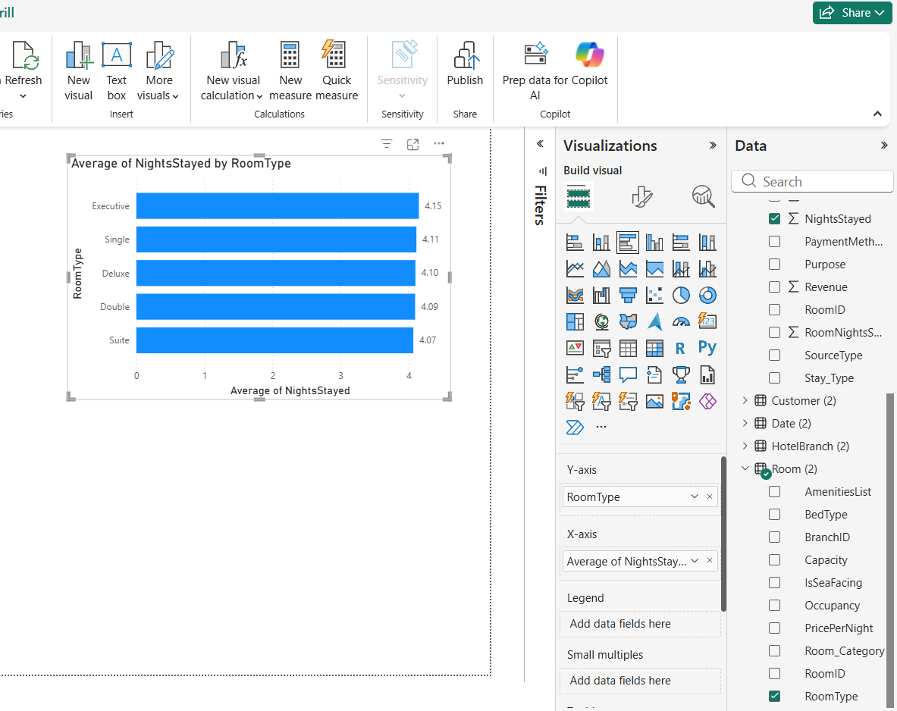
  - Go to the Format pane $→$ Data labels and toggle them On.
4.3 Count of NightsStayed by BranchID
- Select Visual: Click on the Clustered Column Chart icon (vertical bars).
- Add Data:
  - X-Axis: Drag BranchID (from the Branch or Bookings table) into the X-Axis.
  - Y-Axis: Drag NightsStayed into the Y-Axis
- Configure Aggregation:
  - Click the arrow next to NightsStayed in the Y-Axis well and select Count.
- Formatting:
  - Turn on Data labels in the format settings.
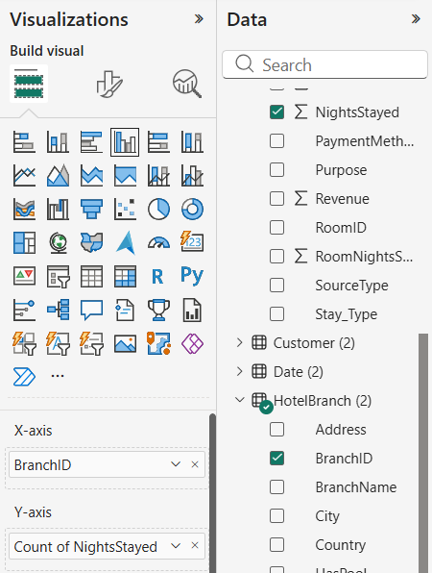
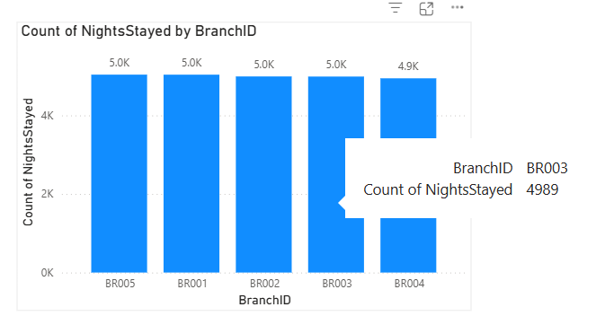

4.4 Sum of Revenue by BranchName
- Select Visual: Click on the Line Chart icon.
- Add Data:
  - X-Axis: Drag BranchName (e.g., "HotelRev Bengaluru") into the X-Axis well.
  - Y-Axis: Drag Revenue (or Total Amount) into the Y-Axis well.
- Configure Aggregation:
  - Ensure the aggregation is set to Sum.
- Formatting:
  - Data Labels: Turn On data labels.
  - Display Units: If the numbers appear as long strings,
  - go to Format $→$ Data labels $→$Values $→$Display units and select Billions (bn).
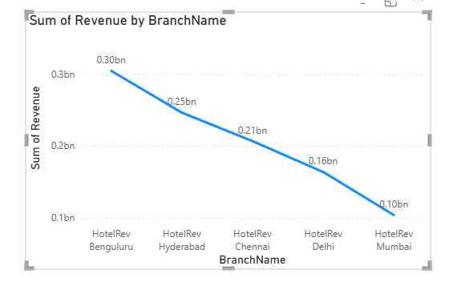
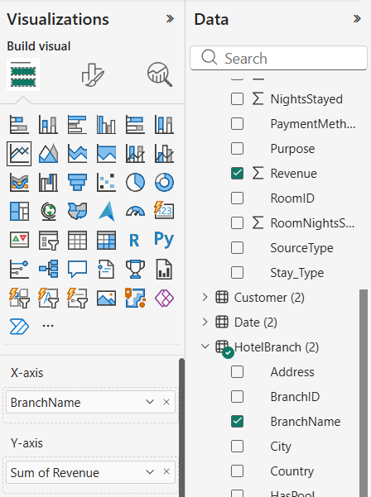

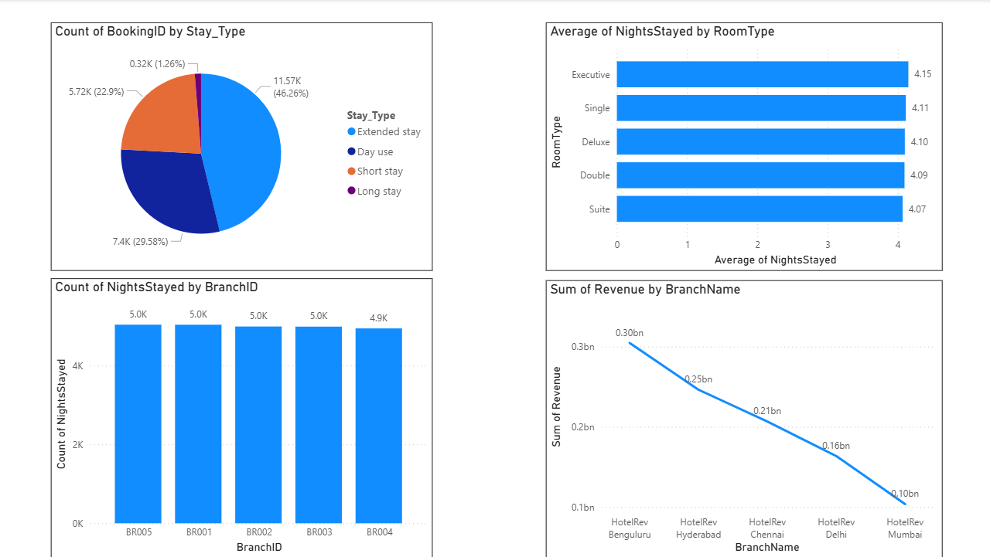

5. Insights:

5.1 Guest Stay Preferences (Pie Chart)
- Dominance of Extended Stays: The largest segment of guests falls into the "Extended Stay" category (Blue slice), accounting for 52.24% (13.06K bookings). This indicates the hotel is popular for guests staying between 3 to 5 days, possibly for business weeks or short vacations.
- Significant "Day Use" Market: Interestingly, 19.95% (4.99K) of bookings are for "Day Use". This suggests a strong demand for transit stays or business day-use facilities,

- Low Long-Term Dependency: Only 1.78% of bookings are "Long Stays" (6+ days), meaning the hotel relies on high turnover rather than long-term residents.

5.2 Room Duration Consistency (Horizontal Bar Chart):

- Uniform Length of Stay: The "Average of Nights Stayed" is remarkably consistent across all room types, hovering tightly between 4.07 and 4.15 nights.

- Interpretation: Whether a guest books a "Single" room or a luxury "Suite," they tend to stay for the same amount of time. Upselling to premium rooms does not necessarily extend the duration of the stay.

5.3 Operational Load vs. Revenue (Vertical Bar vs. Line Chart)
- Even Operational Load: The vertical bar chart (Count of NightsStayed by BranchID) shows that all five branches (BR001–BR005) handle a nearly identical volume of nights (approx. 5.0K each). No single branch is significantly busier than the others in terms of occupancy.

- Revenue Disparity: Despite having similar occupancy levels, the Line Chart (Sum of Revenue) reveals a massive disparity in earnings:
  - Top Performer: Bengaluru is the highest earner at 0.30bn.
  - Lowest Performer: Mumbai is the lowest at 0.10bn.

- Key Finding: Bengaluru generates 3x the revenue of Mumbai despite having roughly the same number of nights stayed. This implies that Bengaluru likely commands a much higher Average Daily Rate (ADR) or sells significantly more premium inventory compared to Mumbai.

6.Conclusion:
The Module 1 analysis successfully established a Star Schema data model and visualized the initial performance metrics. The data reveals a hotel chain with stable operational volume across all locations but volatile revenue efficiency.

